

Welcome to Standards Australia
Onboarding Booklet

How to use this book

Contents Page

A message from our CEO
Welcome to our team, I’m Adrian O’Connell CEO of Standards Australia

We are Australia’s leading developer of Australian Standards! Standards are a critical yet an often unnoticed part of Australian life. They are quality and safety benchmarks that we develop with the assistance of industry and the community.

With over 5,000 publications, our documents provide the standard for everything from child car seats, to mining equipment for explosive environments! We also ensure Australia has a voice in the development of International Standards, being Australia’s representative for the International Organization for Standardization and the International Electrotechnical Commission.

We are a highly skilled and diverse workplace, our team is made up of 140 staff and thousands of contributors all working together to support the Net Benefit of Australian community.

Our core values underpin everything we do and are summed up with the phrase iCARE: integrity, courage, accountability, respect and excellence. Meaning, what we do is just as important as how we do it.

Our goal is to develop standards that benefit all Australians, by enhancing economic efficiency, international competitiveness and contributing to a safe and sustainable environment.

I’m proud of the work we do and the people who do it, I look forward to working with you.

Adrian O’Connell
Acting CEO Standards Australia

01
Day One
First day contents page

Welcome!
<Welcome message>

Today’s Agenda

HR Induction
Date | Meeting/Activity | Person Responsible | Notes
 | - New starter Welcome & Induction  - HR paperwork  - Hours of work  - Building Security (entry /exit)  - Show fire exits, first aid kits and facilities  - Evacuation procedures  - Introduction to First Aid Officers and Fire Wardens  - Pre Existing Conditions/ Confidentiality (PEEP)  POLICY & PROCEDURES  - Duty of Care (tripping hazards, shredder, replenish printer paper etc.) Office management  - EEO/ Harassment / Discrimination Policy  - Social Media Usage  - Dress Code  - Policies and procedures on internal intranet (confluence)  - Smoke Free Environment  - Manager telephone numbers/ buddy in case not here. HR 9237 6186  - Sick or running late procedures  - Medical Certs req. if Monday or Friday – refer to policy  - Staff Christmas leave  - Picnic day  - Rest breaks/Lunch breaks  FINANCE  - Pay schedule (fortnightly)  - Employment Hero emergency contacts and personal information / Leave Requests and entitlements  - Cost code & Chart of Accounts  - Credit cards / Expenses  TECHNOLOGY  - Mobile Phones  - Use of phones/internet, office equipment  - Skype / Office 360  - Meeting Room Bookings on outlook  - Ergonomics, chair set up  - FYI / Confluence Overview  LEARNING & DEVELOPMENT  - Performance & Development Frameworks and cycle  - Capability Frameworks/ KPI’s  - SA Academy  - Ongoing training  MISC. ITEMS  - Staff Briefings (All staff)  - Coffee Machine  - Bicycle Parking / Showers / Access to basement  - Fresh Fruit/Lunch leftover  - Monika Kamycka photo for Scoop, newsletter  - Social Scene  - End of Year Party | (HR Representative)  Julia Flaherty (Head of Finance)  I.T. Team | Ask for proof of ID – take copy  Check all forms have been filled in correctly (Esp. tax & Super)  3.30pm – photo at Ground Floor reception for permanent security pass  Walk to muster point with new starter  Please see floor plan  Any facilities or office management queries should always go to Ariella Mitchell Ext 6084  Pls. input emergency contacts & update any address/personal mobile changes  Check confluence for details  I.T. Induction is scheduled  Functions team coordinate these events

Who is Standards Australia?
Standards Australia is the country’s leading independent, non-governmental, not-for-profit standards organisation.
We are specialists in the development and adoption of internationally-aligned standards in Australia.
We ensure the country has a voice in international standards development, as Australia’s representatives of the International Organization for Standardization (ISO) and International Electrotechnical Commission (IEC).

What is a Standard?

Why are Standards Important?

History of Standards

Our Mission
To excel in the provision of contemporary, internationally aligned Australian Standards and related services.

Our Vision
Standards Australia delivers widely recognised and demonstrated value to Australia’s economic efficiency, trade and international competitiveness and to the community’s expectation of a safe and sustainable Australia.

Our Values
The iCARE values drive our culture and are the linchpin for success in the areas of excellent stakeholder service, increased operational efficiencies and workplace happiness. At Standards Australia we strongly advocate that the 'how' we do things is just as important as the 'what' we do.
Integrity | I will always display INTEGRITY in my relationships with co-workers and stakeholders
Courage | I will have the COURAGE to constructively challenge ineffective ways to contribute to innovation in doing so
Accountable | I will embrace a can-do/follow-through attitude and be ACCOUNTABLE all the way
Respect | I will RESPECT myself and others at all times and go out my way to show support and appreciation
Excellence | I will aim for EXCELLENCE and delight my customers every day

Strategic Pillars
To fulfil our mission and vision, the plan focuses our resources on four strategic pillars:
- Reputation and Brand
As the national standards body, Standards Australia is recognised for its contribution to Australian life. We provide an unbiased, transparent and accountable standards setting system. Nationally and internationally our influence and relevance is strong. We are focused, effective and valued for our leadership and results.
INDICATORS OF SUCCESS
- Our peak body status is maintained
- The economic, political and social case for Standards is clearly understood and recognised
- Industry and community leaders value and support our role nationally and internationally
- Our brands are recognised, trusted and respected in Australia, the region and globally
- We are a strong and valued contributor to international and regional standards development and governance activities
- Our organisation is sought out for its insights and thought leadership
- All tiers and levels of government have a heightened awareness of the positive contribution and relevance of Standards Australia
- Experts and those who support them seek to be engaged with us and are our advocates
Standards Development Organisations (SDOs) accredited through the Board’s Standards Development and Accreditation Committee (SDAC) enhance our brand’s value and performance
- Engagement and Performance
Standards Australia is actively engaged with industry, government and community and aware of their contemporary needs. We deliver high quality and high value solutions for the Australian community through the effectiveness and efficiency of our work. Our development and engagement pathways apply our resources equitably across the economy. Our work program integrates the concept of net benefit to the Australian economy as the basis for project selection.
Our work program supports the currency and alignment of our catalogue. Through a focus on continuous improvement we deliver quality documents, drive best practice performance and support our expert contributors.
INDICATORS OF SUCCESS
- Our standards development process is recognised for its integrity and is acknowledged as being open, transparent, efficient and internationally aligned
- We continue to exploit digital and other technology that supports best practice standards development, project management, education and training, and other business operations
- The delivery and publication of our products is contemporary and flexible, and meets users' needs
- Stakeholders continue to support our process for prioritising development work
- Our international engagement and participation is focused and aligned to industry, trade and other national policy needs
- Our commercial services are valued, outcomes-focused and sound. They support our core business and long term sustainability
- Stakeholders across all sectors of the economy are deeply engaged and support our development cycle
- Engagement with the next generation of technical contributors is embraced and our structures attract and retain contributors
- Government funding support for international engagement through the Support for Industry Services (SISO) program is maintained

- Finance and Governance
Standards Australia is financially secure. Our investment corpus is managed to ensure long term sustainability of our business. We live within our means. The composition of our governance bodies is consistent with our role and with community and Member expectations. Our governance processes are best practice.
INDICATORS OF SUCCESS
- Investment portfolio maintained at its real value in perpetuity
- Our member organisations continue to reflect a broad spectrum of stakeholders across all sectors of the economy
- Our Board, Council and leadership teams are diverse and high performing
- We regularly review our Constitution to ensure it remains relevant for the business environment

- People and Culture
Standards Australia has a strong company culture underpinned by core values that are lived every day. Our people are positive, results driven and operate in a dynamic work environment which rewards and recognises personal, team and overall contribution. Our people are skilled professionals delivering consistent service. Collectively we meet our obligations for the safety and wellbeing of our people at work.
INDICATORS OF SUCCESS
- We attract and retain talented and committed people who are motivated and equipped to deliver outstanding stakeholder focussed services
- Stakeholders express broad satisfaction with the professionalism and service of our people
- Our staff survey reflects our success in creating and maintaining a positive, high performance workplace culture

Capability Framework
To fulfil our mission and vision, the plan focuses our resources on four strategic pillars:
- Reputation and Brand
As the national standards body, Standards Australia is recognised for its contribution to Australian life. We provide an unbiased, transparent and accountable standards setting system. Nationally and internationally our influence and relevance is strong. We are focused, effective and valued for our leadership and results.
INDICATORS OF SUCCESS
- Our peak body status is maintained
- The economic, political and social case for Standards is clearly understood and recognised
- Industry and community leaders value and support our role nationally and internationally
- Our brands are recognised, trusted and respected in Australia, the region and globally
- We are a strong and valued contributor to international and regional standards development and governance activities
- Our organisation is sought out for its insights and thought leadership
- All tiers and levels of government have a heightened awareness of the positive contribution and relevance of Standards Australia
- Experts and those who support them seek to be engaged with us and are our advocates
Standards Development Organisations (SDOs) accredited through the Board’s Standards Development and Accreditation Committee (SDAC) enhance our brand’s value and performance
- Engagement and Performance
Standards Australia is actively engaged with industry, government and community and aware of their contemporary needs. We deliver high quality and high value solutions for the Australian community through the effectiveness and efficiency of our work. Our development and engagement pathways apply our resources equitably across the economy. Our work program integrates the concept of net benefit to the Australian economy as the basis for project selection.
Our work program supports the currency and alignment of our catalogue. Through a focus on continuous improvement we deliver quality documents, drive best practice performance and support our expert contributors.
INDICATORS OF SUCCESS
- Our standards development process is recognised for its integrity and is acknowledged as being open, transparent, efficient and internationally aligned
- We continue to exploit digital and other technology that supports best practice standards development, project management, education and training, and other business operations
- The delivery and publication of our products is contemporary and flexible, and meets users' needs
- Stakeholders continue to support our process for prioritising development work
- Our international engagement and participation is focused and aligned to industry, trade and other national policy needs
- Our commercial services are valued, outcomes-focused and sound. They support our core business and long term sustainability
- Stakeholders across all sectors of the economy are deeply engaged and support our development cycle
- Engagement with the next generation of technical contributors is embraced and our structures attract and retain contributors
- Government funding support for international engagement through the Support for Industry Services (SISO) program is maintained

- Finance and Governance
Standards Australia is financially secure. Our investment corpus is managed to ensure long term sustainability of our business. We live within our means. The composition of our governance bodies is consistent with our role and with community and Member expectations. Our governance processes are best practice.
INDICATORS OF SUCCESS
- Investment portfolio maintained at its real value in perpetuity
- Our member organisations continue to reflect a broad spectrum of stakeholders across all sectors of the economy
- Our Board, Council and leadership teams are diverse and high performing
- We regularly review our Constitution to ensure it remains relevant for the business environment

- People and Culture
Standards Australia has a strong company culture underpinned by core values that are lived every day. Our people are positive, results driven and operate in a dynamic work environment which rewards and recognises personal, team and overall contribution. Our people are skilled professionals delivering consistent service. Collectively we meet our obligations for the safety and wellbeing of our people at work.
INDICATORS OF SUCCESS
- We attract and retain talented and committed people who are motivated and equipped to deliver outstanding stakeholder focussed services
- Stakeholders express broad satisfaction with the professionalism and service of our people
- Our staff survey reflects our success in creating and maintaining a positive, high performance workplace culture

Our Team
International and corporate services
Strategy and Engagement
Operations
Standards Australia Board
Adrian O’Connell
CEO

International and Corporate Services
Within the International and Corporate Services team is the following departments:
ICON | Finance | ICON | Legal | ICON | International Engagement
ICON | Events | ICON | Human Resources +  Learning and Development

Strategy and Engagement
Within the Strategy and Engagement team is the following departments:
ICON | Stakeholder Engagement | ICON | Licensing | ICON | Government Relations
ICON | Public Affairs  and Graphic Design

Operations
Within the Operations team is the following departments:
ICON | Information  Technology | ICON | Publishing | ICON | Editing
ICON | Standards Development Policy, Quality and Services | ICON | Standards Development | ICON | Product

Our Culture

Reward and Recognition Program

Events
Within the International and Corporate Services team is the following departments:
<Photos of Events>

Benefits
ICON | Salary Sacrificing | Employees can maximise take home salaries by taking advantage of SA’s tax status as a rebatable organisation. Depending on salary threshold, employees can sacrifice items such as: Rent and mortgage, Personal Loans and other regular payments, Novated Motor Vehicle Leases, Laptops for business use, Financial Planning services
ICON | Flu Vaccination | Employees elect to have flu vaccinations ahead of the flu season.
ICON | Education Assistance Program | Subject to specific negotiation and budget approval, part payment of tertiary (or equivalent) course plus access to exam leave will be considered. For consideration, courses must be relevant to the employees current role or planned development
ICON | Reward and Recognition Program | Peer and recognition program and incentive prices
ICON | Learning and Development | Vocational, educational or similar access to training opportunities.
ICON | Parental Leave | A paid parental leave scheme where entitlements are stepped according to tenure. Staff who have worked for SA for 12 months or more are eligible
ICON | Standards Australia Social Scene | Participation in core and non-core SA social scene initiatives.
ICON | Skin Check | Employees elect to have an onsite skin check to detect the early signs of disease to allow early intervention and treatment.
ICON | Flexible Work Arrangements | Flexibility around working arrangements subject to business case and approvals
ICON | Emergency Services Leave | Where negotiated in advance and subject to specific budget provision, limited leave to attend obligations where employees have signed up for specific volunteering services
ICON | Employee Assistance Program | Access to counselling service, for employees and immediate family.
ICON | Fruit Provisions | Access to fruit at SA’s office twice weekly.

Who’s who in the zoo?
Map of Level 10 teams

What’s on Level 10
Map of Level 10 facilities

How to use the Coffee Machine
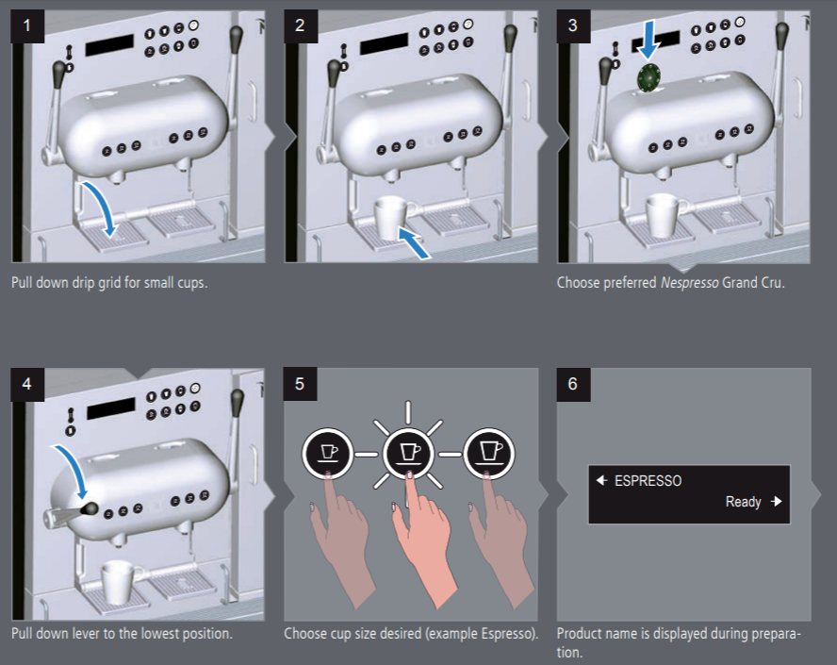
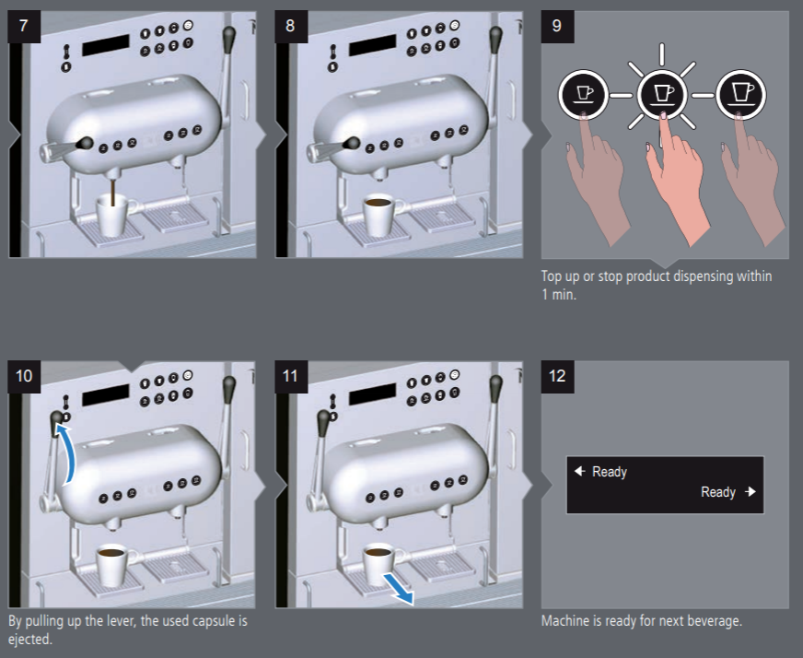

For Milk-based Coffees
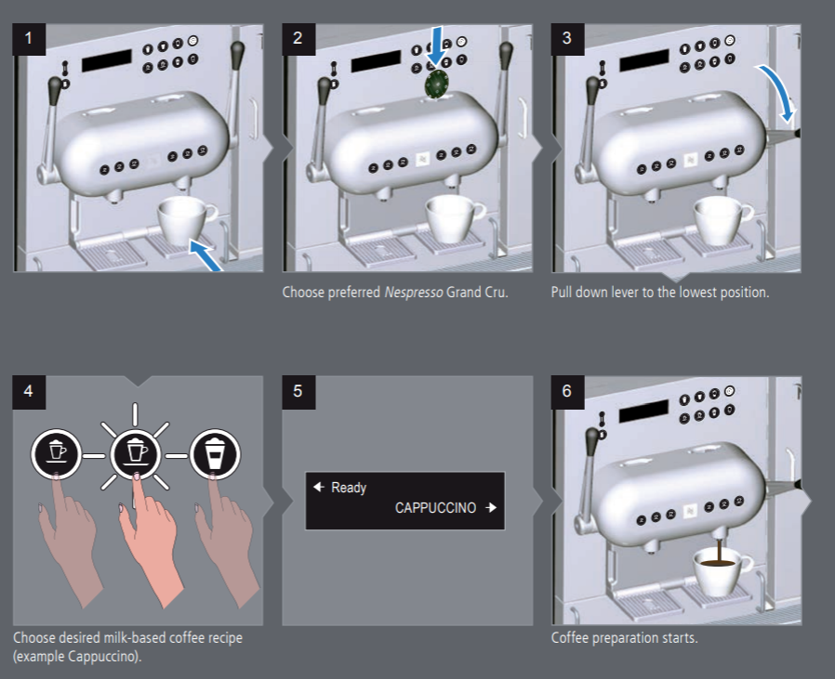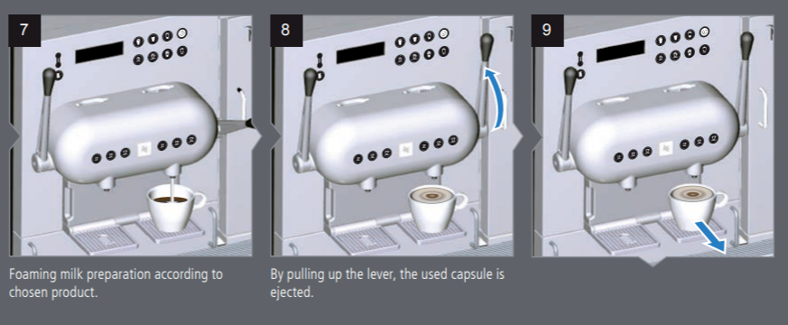

Meet Your Buddy
You have been assigned a buddy! Your buddy is someone from your team that is here to guide you through your first week, introduce you to your stakeholders and be a source of knowledge for any additional questions you may have.

Over a coffee let’s get to know them!

What is your buddy’s name?

How long have they been at Standards Australia?

What is their role? and what are their deliverables?

What did they find most challenging when the first joined Standards Australia?

What do they enjoy most about working for Standards Australia?

What are their hobbies outside of work?

Meet Your Team
What is the name of your team?

What is the function of your team?

How does your team contribute to Standards Australia’s Vision and Values?

What are some of the team building / culture activities or initiatives that your team has been a part of?

IT Induction
SOE | Standard Operating Environment | Introduction
 | Non Administrative access | No C drive access nor RUN command
 | Centrally managed settings | D – Private Data Only partition
Outlook | Introduction | - Show location of Calendar, Public Folders, Out of Office etc.  - How to Create an Outlook Meeting Request with a Room  - How to View Room Availability in Outlook without Creating a New Meeting
Network drives | S (= SA), T (=templates) U (= home drive), etc.
Confluence internal intranet | https://confluence.standards.org.au/ | - Floorplan - Level 9  - Floorplan - Level 10 | Employment Hero
 | Information Technology Confluence page – Forms, there are multiple resources available
Phones | How to: New call, Look up Directories | Audio and web conference facilities
 | Dial outside line, Transfer call
 | Setup voicemail, Check messages button, what is the PIN
 | Check messages from outside (0292376199, *, ext, PIN)
 | Reception 6000
 | Service Desk 6161
 | servicedesk@standards.org.au
Skype |  | Skype for Business Quick Reference Guides
Mobile Phone | Issued to Senior/Management staff - inc’ Standards’ emails | IT, Mobile Phone, Data Usage and Social Media Policy (WP010)
Printers | Locations, Scanning to email, Fax 6010
Remote access | Webmail Address = https://outlook.office365.com/ | Accessing webmail
 | VPN: Cisco AnyConnect | VPN connection to SA network
 | USB Modems are available for Remote access from Team Leader
 | Telstra Next G national internet access modem card – USB type
Miscellaneous | Meeting Room Equipment – Floor boxes, AMX panel, Screen and Projector controlled with “Laptop” button and “Off” button
 | Clifton’s outline then refer to Cliftons information on Confluence

Confluence
Confluence is Standards Australia’s intranet.
It is a one stop shop for information, procedures, processes, guides and forms from every area of the organisation.

Confluence is something that everyone in the business uses on a daily basis, it is important that you get comfortable using Confluence as quickly as possible

Complete the following tasks (ask you buddy for help where required)

Tick when complete
Locate my team page on Confluence
Locate the workplace policies and procedures page
Locate our meeting room booking guidelines
Locate information on Standards Australia’s brand and logo

Introduction to Standards Academy
<Instructions to go to Standardsacademy.litmos.com.au>
We think it’s important that you understand the World of Standards and our business. To get everything started, there is complete the "Welcome to Standards Australia!" learning path in the Standards Academy.
If you are on the work Wi-Fi, when you visit the site – you will automatically login. However, if you are on a different Wi-Fi, you will need to login using your work email and Windows password. Standards Academy is on the cloud, so you can access it on any device, where there is an internet connection.
Ample time should be available for you, in your work schedule, to complete them. Don’t hesitate to write down any questions or comments you have to ask your manager.
Also, as part of the Standards Academy, you have access to the full catalogue in LinkedIn Learning. To get started go to the LinkedIn Learning website and login using your work email and Windows password. If it prompts you for a domain – use standards.org.au

How to access LinkedIn Learning for the first time
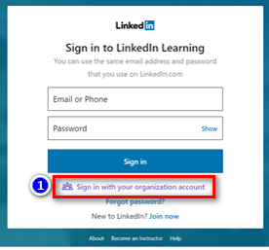 | Step 1 | - Visit the LinkedIn Learning Homepage  Link: https://www.linkedin.com/learning/me  - Click "Sign in with your organization account" under the Sign In button
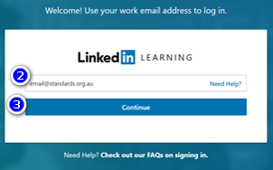 | Step 2  Step 3 | - Enter your Standards work email (eg. email@standards.org.au)  - Click "Continue" to proceed
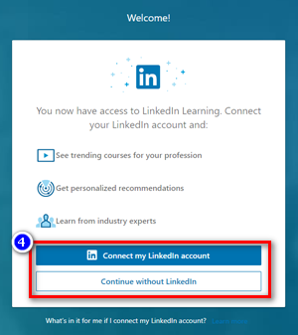 | Step 4 | - Here, you have to two options:  - Connect my LinkedIn account: This will sync your LinkedIn Learning to your personal LinkedIn profile. This is recommended if you want to share your completed course achievements to your LinkedIn network  - Continue without LinkedIn:  If you do not have a LinkedIn account, and do not wish to create a LinkedIn account, this option is recommended.
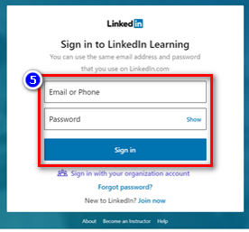 | Step 5 | - If you selected to “Connect your LinkedIn account”, you will be redirected to the LinkedIn login page, where you will enter your personal LinkedIn account details and password.  - Click Sign in once you have entered your details. (No need to click "Sign in with your organization account on this page")
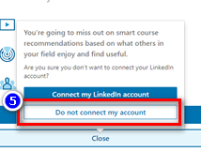 | Step 5 | - If you wish to “continue without a personal LinkedIn account”, you will be prompted to confirm your decision. Click "Do not connect my account" if you wish to proceed.
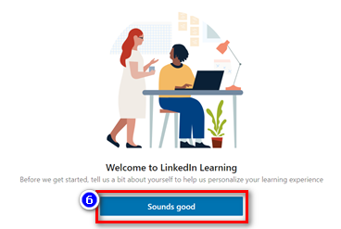 | Step 6 | - You will be redirected to the on-boarding screen.  - Click “Sounds good” to proceed.
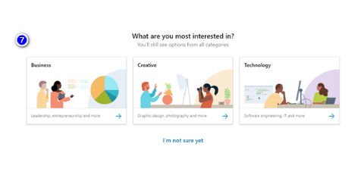 | Step 7 | - The next couple of pages will prompt you to select what type of subjects are you interested in, so it can personalise your profile to suggest what courses you may be interested.
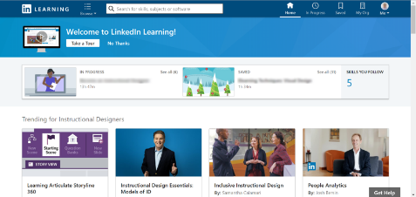 | Step 8 | - Once you have selected your interested subjects, you will be redirected to the main login page, as shown on the left.

The Scoop
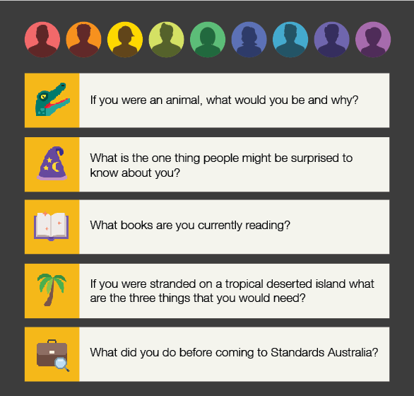

REMINDER
At 3.30pm today, you will have your photos taken downstairs. Head straight to reception (Press 0 on the elevator keypad). Don’t forget to bring your pass with you.
When you arrive tomorrow morning, go to the reception desk to pick up your pass.

End of First Day!
Congratulations! You have reached the end of your first day!
Picture of trophy

Before you leave for the day, check in with your buddy and have a short chat about your day today.
3 things I learnt today… | My goal for tomorrow…

02
Week One
Your first week Contents Page
Welcome Back!

‘Your First Day’ was about getting you settled and introducing you to Standards Australia as a company.
This section of your onboarding guide is about helping you get a deeper understanding of your role, you key stakeholders and introducing you to the world of Standards.

Module 1: Introduction to the World of Standards
Module 1 Thumbnail

What are your 3 major take outs from this module?

What are 3 follow up questions you have for your Buddy regarding the information in this module?

Module 2: Standards Development Process
Module 2 Thumbnail

What are your 3 major take outs from this module?

What are 3 follow up questions you have for your Buddy regarding the information in this module?

Module 3: Roles and Responsibilities in Standards Development Process
Module 3 Thumbnail

What are your 3 major take outs from this module?

What are 3 follow up questions you have for your Buddy regarding the information in this module?

The Learning Academy
During this session, you will meet with Brendan Slowey to discover how the Learning and Development Team is responsible for the development, coordination and/or delivery of the Standards development related education to staff, technical committee members and other Standards Australia stakeholders.

Questions to ask

Notes

Finance Introduction
During this session, you will meet with Brendan Slowey to discover how the Learning and Development Team is responsible for the development, coordination and/or delivery of the Standards development related education to staff, technical committee members and other Standards Australia stakeholders.

Questions to ask

Notes


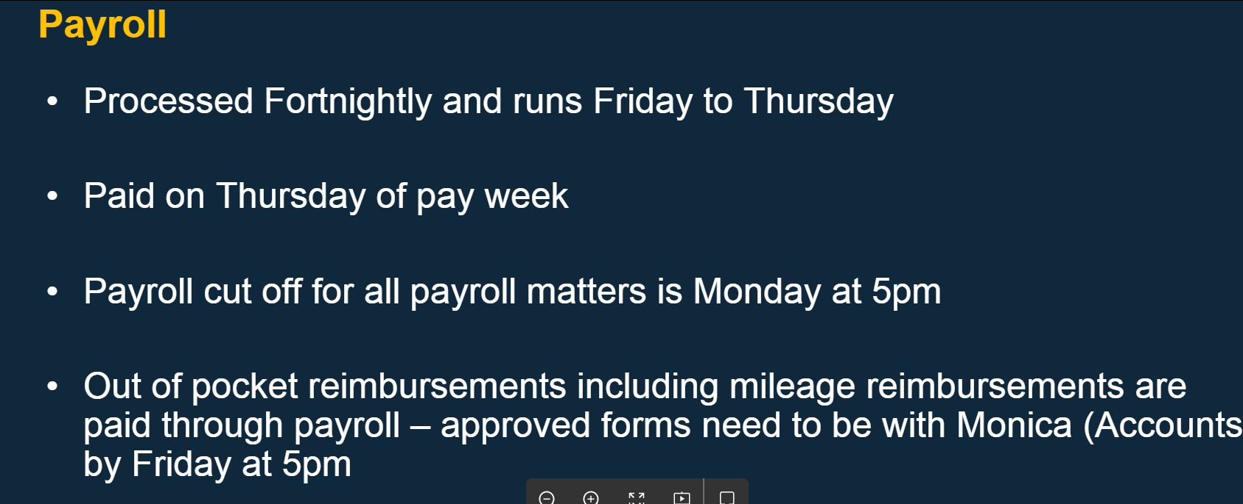
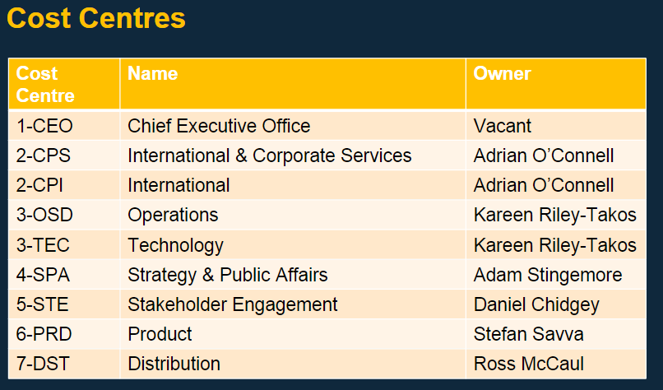
<Info about Accounts Payable>

Facilities Introduction
During this session, you will meet with Anjelica Karagiannis who will give you a tour guide of Level 9 to give an overview of functions and meeting rooms.

Questions to ask

Notes

Map of Level 9

Capability Framework
Input the People Capabilities for your role.
Capbability | Suggested Grade | Goal Grade

Introduction to Standards Guides
Our Standardisation Guides set out the policies and processes for the development of standards and other technical documents.
Code | Name | Description
SG-001 | Preparing Standards | This guide describes:  - General policies and processes for both Australian and joint Australian/New Zealand Standards
SG-002 | Structure and Operation of Standardisation Committees | This guide describes:  - The basic structure of committees  - The processes by which committees are set up and maintained
SG-003 | Standards and Other Publications | This guide describes:  - The range of possible outcomes from the standardisation process  - The purpose and structure of Standards  - Other technical publications
SG-004 | Roles and Responsibilities in Standardisation | This guide describes:  - The operational roles and responsibilities of all participants, including: Committee members, Nominating organisations and Project managers
SG-005 | Technical Governance and Advisory Structures for the Standards Development Process | This guide describes:  The governance of Standards Australia’s development activities
SG-006 | Rules for the Structure and Drafting of Australian Standards® | This guide describes:  Rules for the structure and drafting of both Australian and joint Australian/New Zealand Standards
SG-007 | Adoption of International Standards | This guide describes:  The adoption process of International Standards as Australian or joint Australian/New Zealand Standards
SG-009 | Preparation of Standards for Legislative Adoption | This guide describes:  - How standards should reflect the needs of the Australian community and government  - Guidelines for committees developing standards that may be referenced in Workplace Health and Safety (WHS) legislation to ensure consistency with legal requirements in Australia  - How to develop Australian Standards® referenced by water utilities that meet their contractual or regulatory requirements
SG-015 | Australian Involvement in International Standardisation | This guide describes:  - Australia's participation in preparing international Standards through ISO and IEC  - A summary of the international procedures
SG-020 | Participation by Consumers in Standardisation | This guide describes:  - The role of the consumer representative on a technical committee

Download any of the Standardisation Guides above at: https://www.standards.org.au/standardisation-guides

Buddy Catch-Ups

Day 2
3 things I learnt today… | My goal for tomorrow…

Day 3
3 things I learnt today… | My goal for tomorrow…

Day 4
3 things I learnt today… | My goal for tomorrow…

End of Week Catch-Up
3 things I learnt today… | My goal for next week…

What did you enjoy most about Week 1?

Are there any changes, additional topics or enhancements you would include for Week 1?

Additional Comments

03
Your first month
First Month Contents Page
Welcome Back!

‘Your First Week’ was about developing your understanding your role, your key stakeholders and the world of Standards.
This section of your onboarding guide will be used for the remainder of your probation period. It will focus on providing you with a deeper understanding of Standards, a chance to observing the Standards Development Process through Committee meetings, shadowing others to get a deeper understanding of different roles at Standards Australia and regular meetings with your Manager to get feedback on your performance and plan your development.
<Needs to be updated>

Ask Me Anything Roundtable – Stefan
During this session, you will meet with Stefan Savva, the Head of Product. Feel free to jot down any questions you may have below and write some notes in the space provided.

Questions to ask

Notes

Ask Me Anything Roundtable – Kareen
During this session, you will meet with Stefan Savva, the Head of Product. Feel free to jot down any questions you may have below and write some notes in the space provided.

Questions to ask

Notes

Ask Me Anything Roundtable - Adam
During this session, you will meet with Stefan Savva, the Head of Product. Feel free to jot down any questions you may have below and write some notes in the space provided.

Questions to ask

Notes

Ask Me Anything Roundtable - Adrian
During this session, you will meet with Stefan Savva, the Head of Product. Feel free to jot down any questions you may have below and write some notes in the space provided.

Questions to ask

Notes

World of Standards
In this face to face module you will delve deeper into what is a standard, the standards development process and the parties involved in creating a standard.

During week 1 you would have booked attendance for this session.

What are your 3 major take outs from this module?

What are 3 follow up questions you have for your Buddy regarding the information in this module?

How to Write an Australian Standard
In this face to face module you learn the process of developing and writing an Australian Standard.

During week 1 you would have booked attendance for this session.

What are your 3 major take outs from this module?

What are 3 follow up questions you have for your Buddy regarding the information in this module?

Continuing your personal learning journey

Goal | By When | Actions | Success  measures | Progress
What do you want to be able to achieve?  What are the areas you would like to develop? | When will this goal be completed? | What methods and resources you will use to achieve your goals?  e.g. training, shadowing, study etc. | How will you recognise success?  How will you review and measure my improvements? | What have you done that has contributed towards achieving your goal?  Are there any areas for further development?

Monthly Reviews on Employment Hero

Getting to know your stakeholders

It’s important that you get to know the different departments within Standards Australia, their functions and how your team interacts with them.

We have arranged a series of catch ups with your different stakeholders. We’ve provided some questions to help get the conversations started.

Events

Name of the person you spoke to:

How long have they been with Standards Australia?

What is the function of their team?

How do your teams interact?

How does their team contribute to Standards Australia’s Mission, Vision and Values?

Finance

Name of the person you spoke to:

How long have they been with Standards Australia?

What is the function of their team?

How do your teams interact?

How does their team contribute to Standards Australia’s Mission, Vision and Values?

HR, Learning & Development

Name of the person you spoke to:

How long have they been with Standards Australia?

What is the function of their team?

How do your teams interact?

How does their team contribute to Standards Australia’s Mission, Vision and Values?

Product/Incubator

Name of the person you spoke to:

How long have they been with Standards Australia?

What is the function of their team?

How do your teams interact?

How does their team contribute to Standards Australia’s Mission, Vision and Values?

International Engagement

Name of the person you spoke to:

How long have they been with Standards Australia?

What is the function of their team?

How do your teams interact?

How does their team contribute to Standards Australia’s Mission, Vision and Values?

IT

Name of the person you spoke to:

How long have they been with Standards Australia?

What is the function of their team?

How do your teams interact?

How does their team contribute to Standards Australia’s Mission, Vision and Values?

Legal

Name of the person you spoke to:

How long have they been with Standards Australia?

What is the function of their team?

How do your teams interact?

How does their team contribute to Standards Australia’s Mission, Vision and Values?

Policy, Quality & Service

Name of the person you spoke to:

How long have they been with Standards Australia?

What is the function of their team?

How do your teams interact?

How does their team contribute to Standards Australia’s Mission, Vision and Values?

Public Affairs

Name of the person you spoke to:

How long have they been with Standards Australia?

What is the function of their team?

How do your teams interact?

How does their team contribute to Standards Australia’s Mission, Vision and Values?

Publishing and Content Solutions

Name of the person you spoke to:

How long have they been with Standards Australia?

What is the function of their team?

How do your teams interact?

How does their team contribute to Standards Australia’s Mission, Vision and Values?

Stakeholder Engagement

Name of the person you spoke to:

How long have they been with Standards Australia?

What is the function of their team?

How do your teams interact?

How does their team contribute to Standards Australia’s Mission, Vision and Values?

Standards Development

Name of the person you spoke to:

How long have they been with Standards Australia?

What is the function of their team?

How do your teams interact?

How does their team contribute to Standards Australia’s Mission, Vision and Values?

Congratulations on Completing your first month!

04
Your first six months
Six months Contents page
Welcome Back!

‘Your First Week’ was about developing your understanding your role, your key stakeholders and the world of Standards.
This section of your onboarding guide will be used for the remainder of your probation period. It will focus on providing you with a deeper understanding of Standards, a chance to observing the Standards Development Process through Committee meetings, shadowing others to get a deeper understanding of different roles at Standards Australia and regular meetings with your Manager to get feedback on your performance and plan your development.

Shadowing

It is important for us that you have a deep understanding of our business and the functions of different teams that you interact with.
With your manager (or Buddy!) arrange to shadow two people from different departments for a day.

Person 1
Name of the person you shadowed:

What is their role?

What is the function of their team?

Who are their key stakeholders?

What are their most common daily tasks?

How does their team contribute to Standards Australia’s Mission, Vision and Values?

Person 2
Name of the person you shadowed:

What is their role?

What is the function of their team?

Who are their key stakeholders?

What are their most common daily tasks?

How does their team contribute to Standards Australia’s Mission, Vision and Values?

Observing the Standards Development Process

Committee Meetings

Observe at least 5 committee meetings and watch how the Standards Australia employees ensure that these meetings are productive and run smoothly.
Click here to download the Committee Meeting Observational guide.

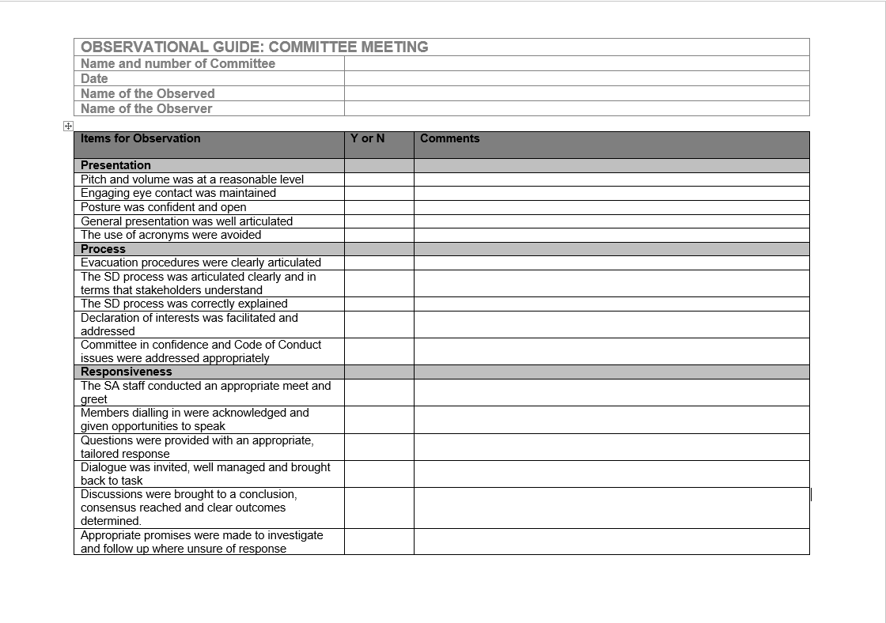

Forums
Make sure you attend a forum to observe another side of the organisation. Forums are generally arranged to determine the need for a standard or to facilitate an industry to reach consensus on the way forward. They are usually held for new and exciting areas of standardisation.

6 months celebration page

Feedback page
Page where you can send your feedback about the booklet to L&D

Back Cover

